Visual Arts Competition & Display

THEME: ***A Journey of 50 years towards the Community with Shared Future: Trinidad and Tobago and China***

**COMPETITION ENTRY FORM**

**Instructions:**

All information must be completed in block letters and must be attached to the art piece at submission.

**STUDENT’S NAME**: ___________________________________________________ DATE **OF BIRTH**: _________________

SURNAME FIRST NAME DD/MM/YYYY

AGE: ____________________ GENDER: M ( ) F ( )

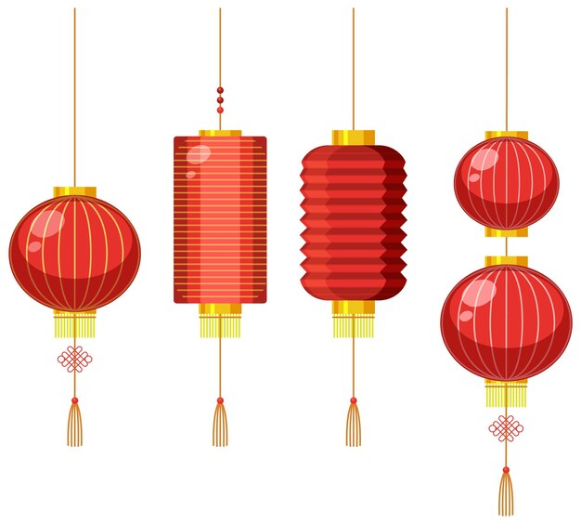

HOME ADDRESS: _______________________________________________________________________________________

**PARENT/GUARDIAN**: ___________________________________________________**HOME TEL**: ____________________

SURNAME FIRST NAME

**PARENT/GUARDIAN CELL(S):** _____________________________ **EMAIL ADDRESS**: ____________________________

**NAME OF SCHOOL: ______________________________________________ TEL: ________________________________**

**PRINCIPAL’S NAME: _____________________________________________**

**SCHOOL’S ADDRESS: ___________________________________SCHOOL’S EMAIL ADDRESS: _____________________**

**ARTWORK TITLE: ______________________________________________________________________________________**

**ARTWORK SIZE: __________________________________________________________________________**

**BRIEF DESCRIPTION OF ARTWORK: ________________________________________________________________________________________________________________________________________________________________________________________________________________________________________________________________________________________________________________________**

**CATEGORY:**

**PRIMARY**

**LOWER SECONDARY (**FORMS 1-3)

**UPPER SECONDARY** (FORMS 4-6)

**ARTWORK ENTRIES**

2D Artwork can be created with paint, chalk, crayon, or collage and must **not be smaller than 40 cm x 55 cm and must not exceed 46 cm x 60 cm.**

The use of oil paints, organic materials, and other dangerous materials such as broken glass, sharp metals etc **is prohibited**.

* All artwork submitted must have attached a completed entry form (all information must be filled).
* All entries must be submitted **the school’s** Educational District Office on **May 24th, 2024.**
* Judging criteria: Craftsmanship (25 marks), Design (10 marks) and Originality (25 marks).
* **The top 4 winners in each category** will be contacted on **10th June 2024.**

**All students’ work becomes the property of the Chinese Embassy**